PLYMOUTH PARKS & RECREATION DEPT

BASIC DOG OBEDIENCE STARTS April 16, 2016 - 5 WEEK PROGRAM

SAT.11:30 A.M -12:30 P.M. WITH VALERIE BILODEAU

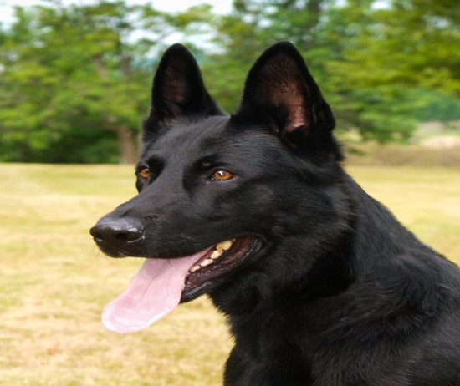 **WHY ARE WE HERE?**

WE COME TOGETHER TO THE FIRST CLASS **WITHOUT** OUR DOGS TO ANSWER ANY QUESTIONS YOU MAY HAVE. I WILL HAVE MY GERMAN SHEPHERD DOG DAUNTE WITH ME TO DEMONSTRATE SOME OF THE EXERCISES THAT WILL BE TAUGHT IN CLASS. IN ORDER TO TRAIN OUR DOGS EFFECTIVELY, WE MUST LEARN HOW TO COMMUNICATE AND INTERACT WITH THEM.

**WHAT CAN YOU EXPECT TO LEARN FROM THIS CLASS**

YOU WILL LEARN HOW TO TRAIN YOUR DOG THE BASIC OBEDIENCE COMMANDS, SIT, DOWN, HEEL, COME, STAND AND STAY. YOU WILL NEED TO WORK WITH YOUR DOG ON A DAILY BASIS TO ACHIEVE THE MAXIMUM RESULTS. CLASS TRAINS YOU, YOU TRAIN YOUR DOG.

**DOGS COMMUNICATE WITH FACIAL EXPRESSIONS, BODY POSTURE AND VOCALIZATION.**

THEY DO NOT SPEAK A “HUMAN LANGUAGE”. THEIR VOCALIZATION IS BARKING, WHINING, GROWLING, ETC. YOUR TONE OF VOICE WILL DETERMINE IF SOMETHING IS GOOD OR NOT GOOD.

**LOUDER IS NOT BETTER!**

**EQUIPTMENT TO BE USED IN CLASS**

FLAT BUCKLE COLLAR, OR TRAINING COLLAR, OR GENTLE LEADER, OR HARNESS. 6 FOOT LEASH. (**no retractable leashes allowed in class)** Bring treats and poop bags.

**WORKING WITH YOUR DOG**

CLASS WILL ONLY PROVIDE THE KNOWLEDGE YOU NEED TO TRAIN YOUR DOG. YOU SHOULD UTILIZE THIS INFORMATION TO SHAPE THE BEHAVIOR OF YOUR DOG WHEN AT HOME. THERE WILL BE HOMEWORK EXERCISES FOR YOU TO DO AT HOME TO CONTINUE THE LEARNING PROCESS.

**FINAL NOTE:**

EVERY WEEK THERE WILL BE A TOPIC OF INTEREST TO DISCUSS AT THE END OF EACH CLASS.

ALWAYS FINISH YOUR TRAINING SESSION ON A POSITIVE NOTE. SET YOUR DOG UP FOR SUCCESS HAVE FUN AND LOTS OF PATIENCE.

C:\Users\valerie\AppData\Local\Microsoft\Windows\Temporary Internet Files\Content.IE5\YYOAXGQL\MC900389178[1].wmf 